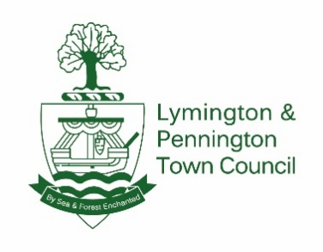
DEPUTY CLERK - JOB DESCRIPTION

Scale range: SCP 29-32
Hours: 25-30 hours per week permanently (to include some evening meetings as necessary)
Reports to: Town Clerk
Location: office based at Town hall, Lymington, although some opportunity to work remotely in line with operational needs of Council
Role Description: To support and proactively assist the Town Clerk with the administration of the Council including its statutory, financial, operational, management and administrative functions.

Main Responsibilities:
1. In order to be able to give accurate advice at Council and Committee meetings the candidate should possess or achieve the SLCC CILCA qualification within 12 months of starting the role. Cost of CILCA training, registration, attendance at courses, coursework and examination process will be met by council, although it is expected that a fair amount of study will be in own personal time.
2. To support the Town Clerk in ensuring statutory and other provisions affecting the running of the Council and to deputise for the Town Clerk as required.
3. To support the Town Clerk’s role as principal advisor to the Council through attendance at Council and Committee meetings as required.
4. To be responsible for such Committees and working parties as instructed, including liaising with committee officer on preparation of agendas, producing supporting papers, attendance at meetings, drafting of minutes and any actions arising from meetings as required.
5. To attend meetings of such other bodies, organisations and groups as may be reasonably required.
6. To engage with third party contractors to carry out work on behalf of the Council by adhering to the local authority procurement and tender process as instructed by the Town Clerk.
7. To oversee management of Council resolved projects and/or services as necessary.
8. To carry out any risk assessments for Council duties or services as requested, and to assist/ provide support to the Town Clerk in preparation of any policies or Governance requirements.
9. To act as line manager and support the administrative officers with their day-to-day responsibilities. This may include assistance with events planning, celebrations, markets and allotment functions.
10. To have knowledge of the Council’s accounting processes and record keeping as necessary to carry out functions of Deputy Clerk.
11. To assist the Town Clerk in ensuring the Council’s responsibilities as an employer are met.
12. To support the Town Clerk in the preparation and administration of the Annual Town Meeting.
13. To undertake personal and professional development relevant to the role.
14. Any other reasonable duties that may be assigned from time to time.

This document sets out the main dimensions of the job it describes. It does not define all individual tasks or priorities, which may be expected to change from time to time to meet operational needs.

